**Getting Started**

**Introduction**

This sub task introduces the learner to the practical knowledge of Cyber Security by going through a series of what is called rooms for a special skill particularly.

***Activities***

***Task 1: Introduction***

This section outlines objectives such as the social media site to be attacked using a virtual machine, the location of the site.

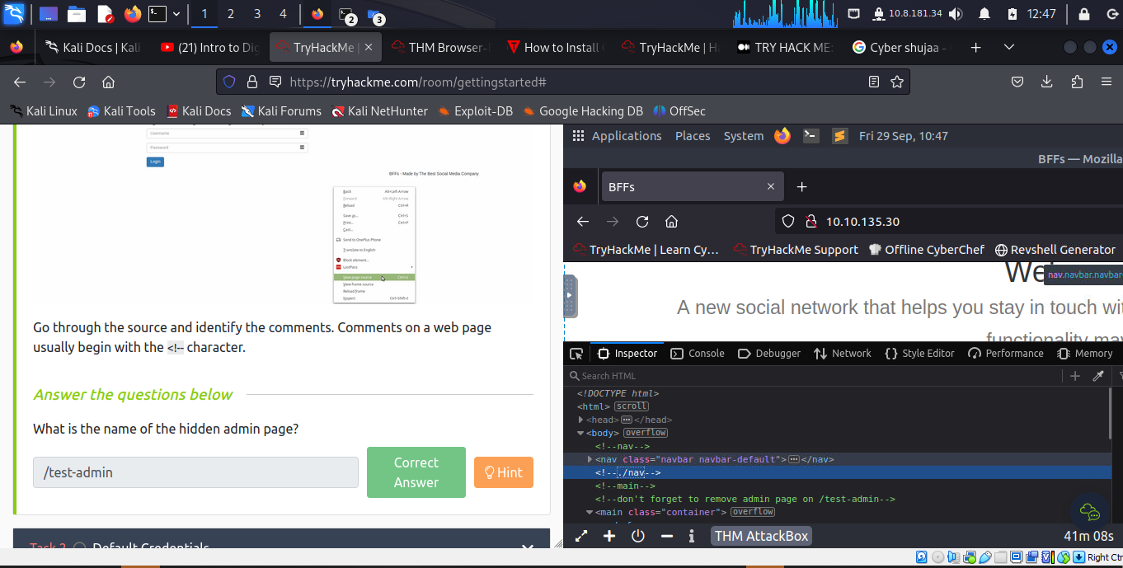

***Task 2: Default Credentials***

This sub task assesses common misconfiguration of the web application by searching for default credentials or by giving a guess.

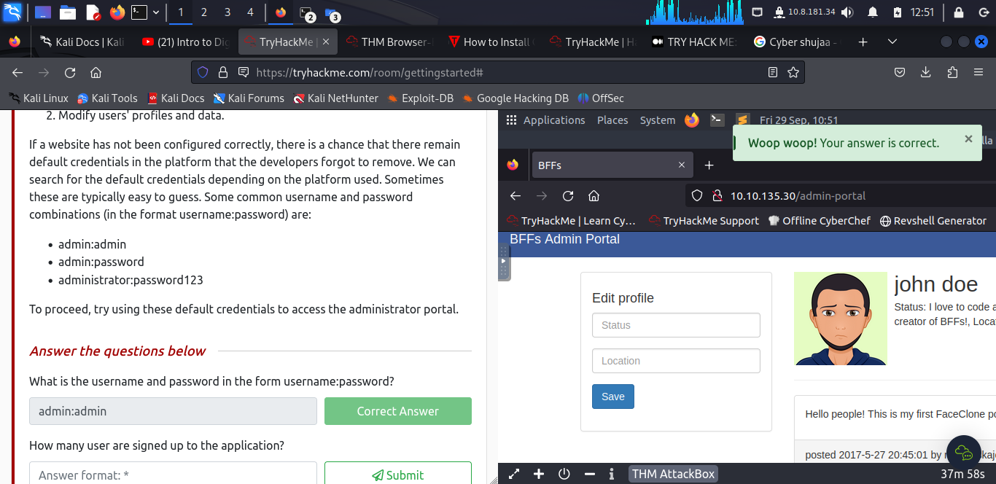

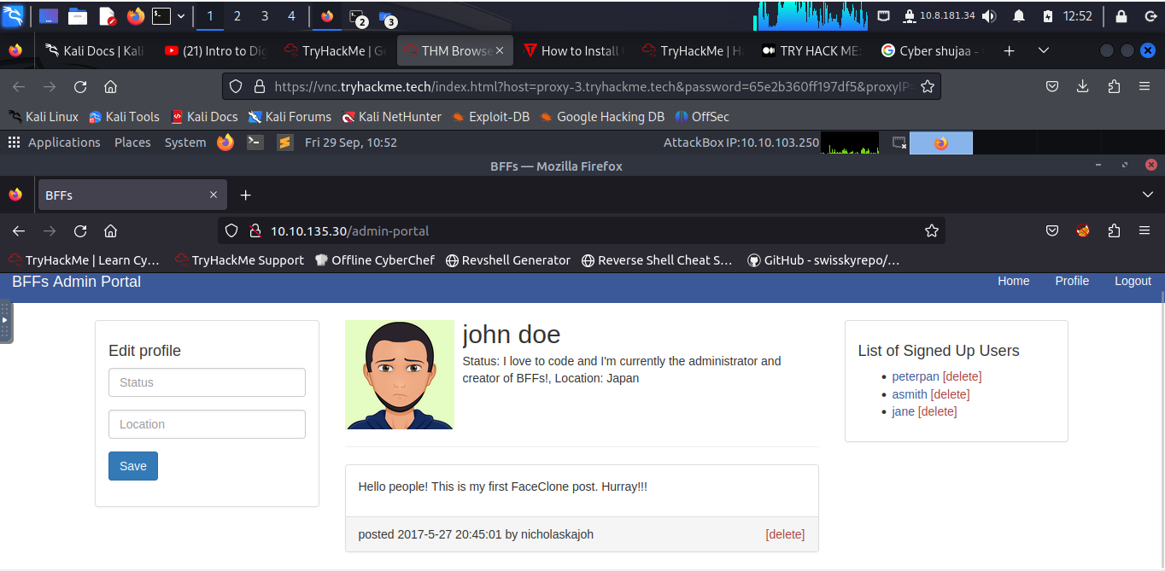

***Task 3: Conclusion***

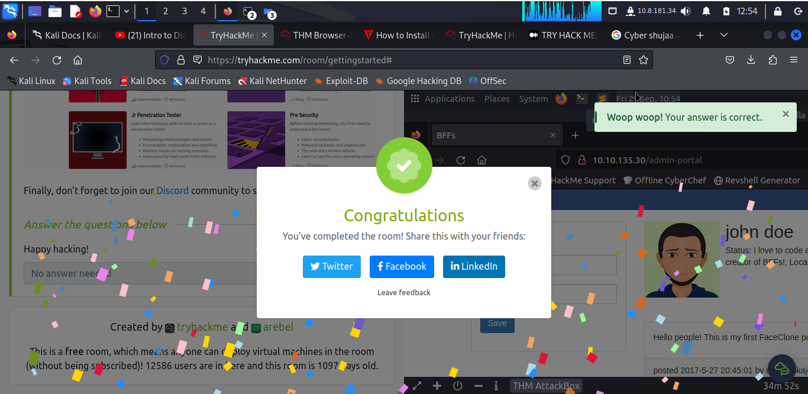

**Conclusion**

This task took the through web vulnerabilities, application misconfigurations and enhanced knowledge in Cybersecurity.